Contestant Number: ____________________
Time: ___________________
Rank: _______________



SYSTEM ADMINISTRATION
USING CISCO
(315)
NATIONAL 2021

CONCEPT KNOWLEDGE:

Multiple Choice (50 @ 10 points each) (500 points)

TOTAL POINTS (500 points)

Test Time: 60 minutes

GENERAL GUIDELINES:
Failure to adhere to any of the following rules will result in disqualification:
- Contestant must hand in this test booklet and all printouts if any. Failure to do so will result in disqualification.
- No equipment, supplies, or materials other than those specified for this event are allowed in the testing area. No previous BPA tests and/or sample tests (handwritten, photocopied, or keyed) are allowed in the testing area.
- Electronic devices will be monitored according to ACT standards.

Identify the letter of the choice that best completes the statement or answers the question.
- Which statement describes the autonomous system number used in EIGRP configuration on a Cisco router?
  - It carries the geographical information of the organization.
  - It functions as a process ID in the operation of the router.
  - It is a globally unique autonomous system number that is assigned by IANA.
  - It identifies the ISP that provides the connection to the network of the organization

- An EIGRP router loses the route to a network. Its topology table contains two feasible successors to the same network. What action will the router take?
  - The DUAL algorithm is recomputed to find an alternate route.
  - The router uses the default route.
  - The best alternative backup route is immediately inserted into the routing table.
  - The router will query neighbors for an alternate route.

- What is the function of OSPF hello packets?
  - to send specifically requested link-state records
  - to discover neighbors and build adjacencies between them
  - to ensure database synchronization between routers
  - to request specific link-state records from neighbor routers

- Refer to the exhibit.
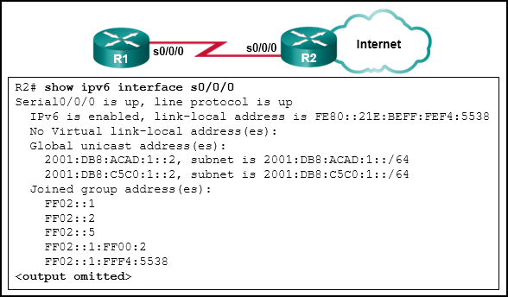
R1 and R2 are OSPFv3 neighbors. Which address would R1 use as the next hop for packets that are destined for the Internet?
  - FF02::5
  - 2001:DB8:ACAD:1::2
  - 2001:DB8:C5C0:1::2
  - FE80::21E:BEFF:FEF4:5538
- What command can be used to verify the number of equal-cost paths currently configured on the router?
  - show ip protocols
  - show ip route
  - show ip interface brief
  - show eigrp brief

- What command is used to verify that the correct EIGRP adjacencies were formed after being configured for authentication?
- show ip route
- show eigrp neighbors
- show ip route neighbors
- show ip eigrp neighbors

- Which of the following commands will create a default route for IPv6?
  - Ipv6 route 2001::1/64 serial 0/1/0
  - Ipv6 route ::1/0 serial 0/1/0
  - ipv6 route ::/0 serial 0/1/0
  - ipv6 route fe80::1/64 serial 0/1/0

- What command is used to display IPv6 routes?
  - Show route ipv6
  - Show ipv6 route
  - Show route
  - Show all route

- What command will configure the bandwidth to 40% for EIGRP ipv6?
- (config)# ipv6 bandwidth-percent eigrp 40
- (config-if) ipv6 bandwidth-percent eigrp 40
- (config)# ipv6 bandwidth-percent eigrp 3 40
- (config-if) ipv6 bandwidth-percent eigrp 3 40

- What method does Cisco use to authenticate routing protocol packets?
  - MD5
  - AES
  - RSA
  - Twofish

- To verify that the correct EIGRP adjacencies were formed after being configured for authentication, what command would you use?
  - Show run
  - show ip eigrp neighbors
  - show ip interface brief
  - show ip eigrp interface

- Refer to the exhibit.
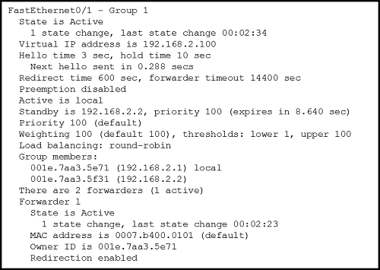
A network engineer is troubleshooting host connectivity on a LAN that uses a first hop redundancy protocol. Which Ipv4 gateway address should be configured on the host?
  - 192.168.2.0
  - 192.168.2.1
  - 192.168.2.2
  - 192.168.2.100

- Refer to the exhibit.
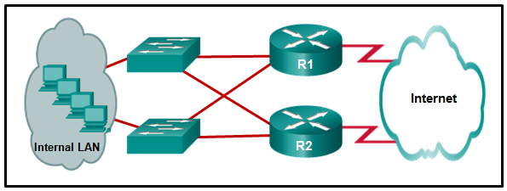
What protocol can be configured on gateway routers R1 and R2 that will allow traffic from the internal LAN to be load balanced across the two gateways to the Internet?
  - STP
  - PVST
  - PVST+
  - GLBP

- What is the purpose of setting the native VLAN separate from data VLANs?
  - The native VLAN is for carrying VLAN management traffic only.
  - The security of management frames that are carried in the native VLAN can be enhanced.
  - A separate VLAN should be used to carry uncommon, untagged frames to avoid bandwidth contention on data VLANs.
  - The native VLAN is for routers and switches to exchange their management information, so it should be different from data VLANs.

- Refer to the exhibit.
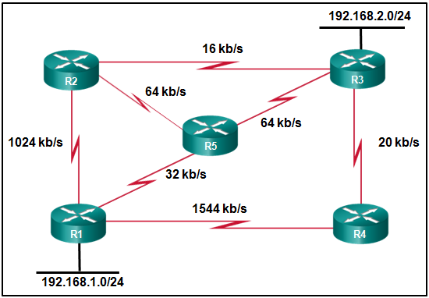
All the routers that are displayed are part of the EIGRP domain. Assuming EIGRP metric weights are not altered in the configurations, which path will a packet take that originates from a host on the 192.168.1.0/24 network and is going to a host on the 192.168.2.0/24 network?
  - R1, R4, R3
  - R1, R5, R3
  - R1, R2, R3
  - R1, R2, R5, R3

- If no bridge priority is configured in PVST, which criteria is considered when electing the root bridge?
  - lowest IP address
  - lowest MAC address
  - highest IP address
  - highest MAC address
- Refer to the exhibit.
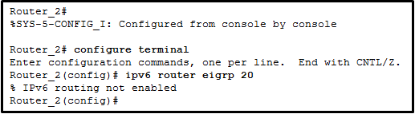
A network administrator is configuring EIGRP AS 20 on Router_2 and has received the error that is shown. What is the cause of the error?
  - The autonomous system (AS) number is not the same as the number on other routers in this network.
  - The Ipv6 routing process cannot be implemented until Ipv6 routing is enabled.
  - The EIGRPv6 interface configuration is incomplete.
  - The passive-interface default command has been implemented for EIGRPv6.

- Refer to the exhibit.
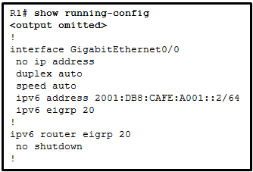
Router R1 has recently been configured to operate in an Ipv6 only network and is connected via interface GigabitEthernet0/0 to router R2. R2 is configured correctly, but will not form a neighbor relationship with R1. What is the problem?
  - The IP address is missing on interface GigabitEthernet0/0.
  - The command ipv6 unicast-routing has not been implemented.
  - The router ID has not been created on router R1.
  - The EIGRPv6 process has not been activated on interface GigabitEthernet0/0.

- What is a characteristic of EtherChannel?
  - EtherChannel uses physical ports that have been upgraded to provide a faster connection.
  - STP will not block redundant EtherChannel bundles between two switches
  - STP treats all interfaces in a bundle as a single logical link
  - EtherChannel configuration is applied to each physical port.

- What is the most likely cause when the output of the show interface command shows that a switch interface is up but the line protocol is down?
  - A cable is not attached to the interface
  - An incorrect default gateway has been configured
  - An encapsulation type mismatch exists
  - An incorrect cable type has been attached to the interface

- Refer to the exhibit.
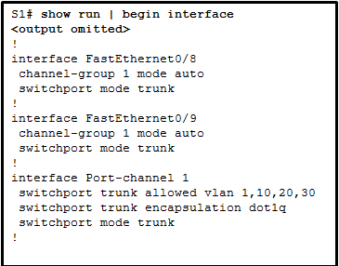
A network administrator is reviewing the configuration of switch S1. Which protocol has been implemented to group multiple physical ports into one logical link?
  - PAgP
  - DTP
  - LACP
  - STP

- Which technology supports CHAP authentication over a dialer interface?
  - GRE
  - PPPoE
  - VPN
  - eBGP

- Which WAN technology can serve as the underlying network to carry multiple types of network traffic such as IP, ATM, Ethernet, and DSL?
  - ISDN
  - MPLS
  - Frame Relay
  - Ethernet WAN

- Which WAN connectivity method would be used in a remote location where there are no service provider networks?
  - cable
  - VPN
  - VSAT
  - WiMAX

- How many 64 kb/s voice channels are combined to produce a T1 line?
  - 8
  - 16
  - 24
  - 32

- Refer to the exhibit.
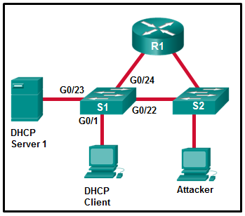
Which interface on switch S1 should be configured as a DHCP snooping trusted port to help mitigate DHCP spoofing attacks?
  - G0/23
  - G0/1
  - G0/24
  - G0/22

- Refer to the exhibit.
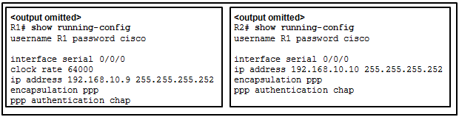
Routers R1 and R2 have been configured for PPP using CHAP as the authentication protocol, but the link will not go to the up and up state. What configuration error has been made?
  - R1 has an incorrect username
  - Both routers are missing the ppp pap sent-username command.
  - One of the routers needs a different password for the specified username.
  - One of the router IP addresses needs to be changed to be on the same network.

- An OSPFv3 router has no Ipv4 addresses configured and the router ID has not been manually set. What is the result of this configuration?
  - OSPFv3 will not start.
  - The highest Ipv6 address of a loopback interface will be used as the router ID
  - The highest Ipv6 address of a physical interface will be used as the router ID
  - The router will automatically generate a router ID using the MAC address of one of the interfaces.

- Which protocol defines port-based authentication to restrict unauthorized hosts from connecting to the LAN through publicly accessible switchports?
  - 802.1x
  - RADIUS
  - TACACS+
  - SSH

- What is the function of STP in a scalable network?
  - It decreases the size of the failure domain to contain the impact of failures
  - It protects the edge of the enterprise network from malicious activity
  - It disables redundant paths to eliminate Layer 2 loops
  - It combines multiple switch trunk links to act as one logical link for increased bandwidth.

- What is the function of ASICs in a multilayer switch?
  - The provide power to devices such as IP phones and wireless access points through Ethernet ports.
  - They streamline forwarding of IP packets in a multilayer switch by bypassing the CPU
  - They prevent Layer 2 loops by disabling redundant links between switches
  - They aggregate multiple physical switch ports into a single logical port
- Refer to the exhibit.
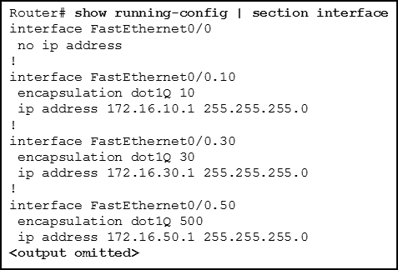
The partial configuration that is shown was used to configure router-on-a-stick for VLANs 10, 30, and 50. However, testing shows that there are some connectivity problems between the VLANs. Which configuration error is causing the problem?
  - A configuration for the native VLAN is missing
  - There is no IP address configured for the FastEthernet0/0 interface
  - The wrong VLAN has been configured on subinterface Fa0/0.50
  - The VLAN IP addresses should belong to the same subnet.
- Refer to the exhibit.
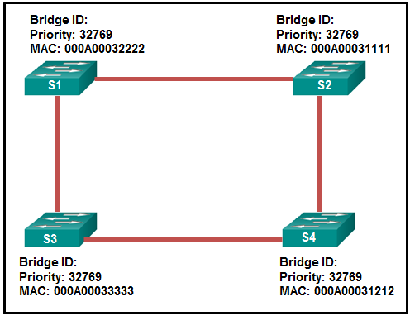
Which switch will be the root bridge after the election process is complete?
  - S1
  - S2
  - S3
  - S4

- Refer to the exhibit.
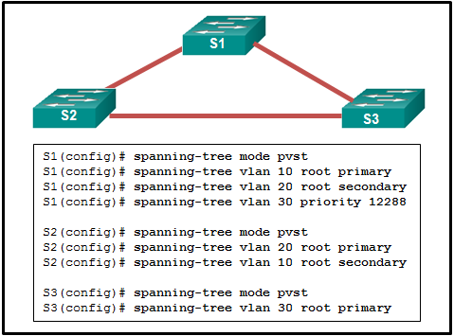
A network administrator is configuring PVST+ for the three switches. What will be a result of entering these commands?
  - S1 will set the priority value for VLAN 10 to 0.
  - S2 will set the priority value for VLAN 10 to 24576.
  - S3 will set the priority value for VLAN 30 to 8192
  - S1 will set the priority value for VLAN 20 to 24596.

- Refer to the exhibit.
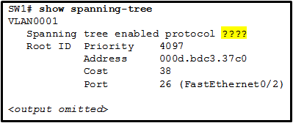
If the switch has been configured for PVST+ mode, what command output would replace the question marks?
  - ieee
  - pvst
  - pvst+
  - rstp

- Which technology is an open protocol standard that allows switches to automatically bundle physical ports into a single logical link?
  - Multilink PPP
  - DTP
  - LACP
  - PagP

- Refer to the exhibit.
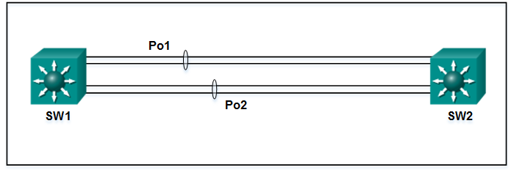
A network administrator has connected two switches together using EtherChannel technology. If STP is running, what will be the end result?
  - The switches will load balance and utilize both EtherChannels to forward packets.
  - STP will block one of the redundant lines
  - The resulting loop will create a broadcast storm.
  - Both port channels will shutdown.

- Refer to the exhibit.
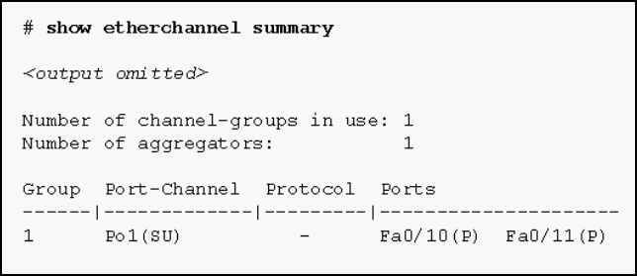
Based on the command output shown, what is the status of the EtherChannel?
  - The EtherChannel is dynamic and is using ports Fa0/10 and Fa0/11 as passive ports.
  - The EtherChannel is down as evidenced by the protocol field being empty.
  - The EtherChannel is partially functional as indicated by the P flags for the FastEthernet ports.
  - The EtherChannel is in use and functional as indicated by the SU and P flags in the command output
- A network engineer is configuring a LAN with a redundant first hop to make better use of the available network resources. Which protocol should the engineer implement?
  - FHRP
  - GLBP
  - HSRP
  - VRRP

- Which dynamic routing protocol uses hop count to calculate metric value?
  - RIP
  - EIGRP
  - OSPF
  - IS-IS

- Refer to the exhibit.
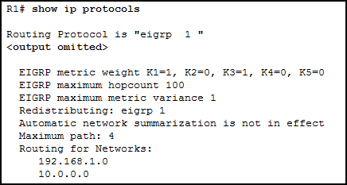
A network administrator issues the show ip protocols command. Based on the exhibited output, what can be concluded?
  - The EIGRP K values are default values
  - R1 receives routes to the network 192.168.1.0/24 and 10.0.0.0/24
  - The no auto-summary command is not applied for the EIGRP operation
  - Up to 4 routes of different metric values to the same destination network will be included in the routing table.

- Which feature of the EIGRP routing protocol can provide fast re-convergence without DUAL recomputation in the event of a route failure?
  - having a successor route
  - having a feasible successor route
  - having a route in the passive state
  - having a route in the active state
- Refer to the exhibit.
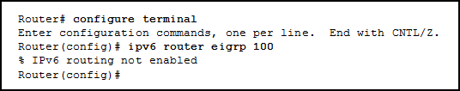
An administrator attempts to configure EIGRP for Ipv6 on a router and receives the error message that is shown. Which command must be issued by the administrator before EIGRP for Ipv6 can be configured?
  - no shutdown
  - eigrp router-id 100.100.100.100
  - ipv6 unicast-routing
  - ipv6 eigrp 100

- Refer to the exhibit.
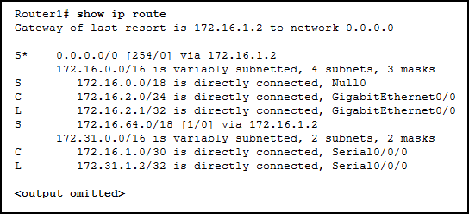
What will Router1 do if it receives packets that are destined to network 172.16.4.0/24?
  - drop the packets
  - forward the packets to the gateway of last resort
  - send the packets out interface GigabitEthernet0/0
  - send the packets to network 0.0.0.0

- In which IOS CLI mode must a network administrator issue the maximum-paths command to configure load balancing in EIGRP?
  - global configuration mode
  - interface configuration mode
  - privileged mode
  - router configuration mode

- Refer to the exhibit.
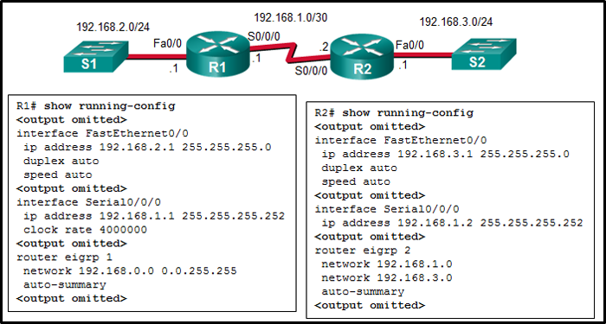
Why did R1 and R2 not establish an adjacency?
  - The AS number does not match on R1 and R2
  - The automatic summarization is enabled on R1 and R2
  - The Ipv4 address of Fa0/0 interface of R1 has a wrong IP address
  - The is no network command for the network 192.168.1.0/24 on R1

- What is the order of packet types used by an OSPF router to establish convergence?
  - Hello, LSAck, LSU, LSR, DBD
  - LSAck, Hello, DBD, LSU, LSR
  - Hello, DBD, LSR, LSU, LSAck
  - LSU, LSAck, Hello, DBD, LSR

- Which wildcard mask would be used to advertise the 192.168.5.96/27 network as part of an OSPF configuration?
  - 0.0.0.32
  - 0.0.0.31
  - 255.255.255.224
  - 255.255.255.223
- Which OSPFv3 function works differently from OSPFv2?
  - metric calculation
  - hello mechanism
  - OSPF packet types
  - authentication
- On what type of OSPF router is interarea route summarization configured?
  - intra-area routers
  - backbone routers
  - ABRs
  - ASBRs

